# Querying the Snowflake Schema (Final Corrected)

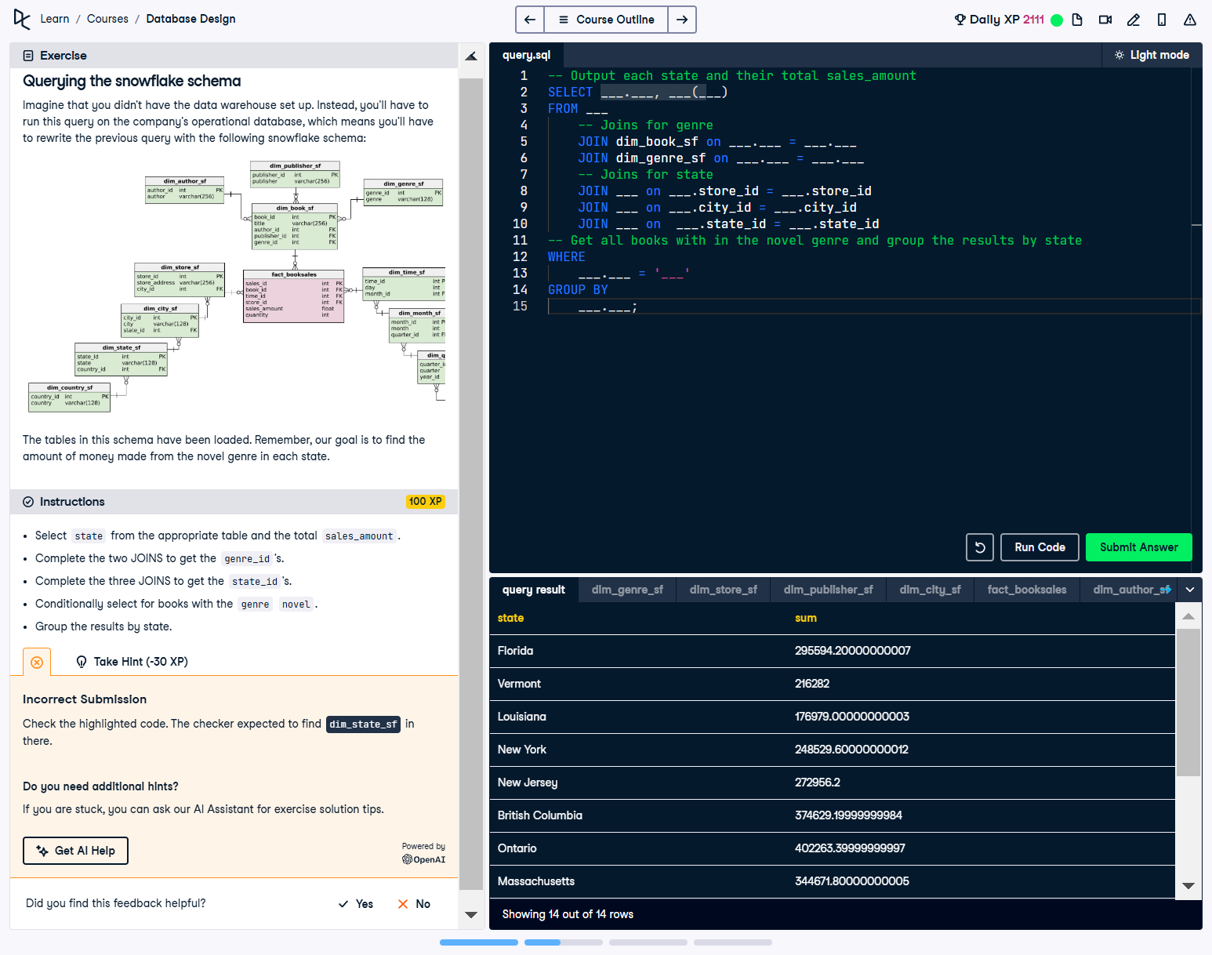

## Question

Imagine that you didn’t have the data warehouse set up. Instead, you’ll have to run the query on the company’s operational database, which means you’ll have to rewrite the previous query with the following snowflake schema:  
  
The tables in this schema have been loaded. Remember, our goal is to find the amount of money made from the novel genre in each state.

Instructions:  
1. Select state from the appropriate table and the total sales_amount.  
2. Complete the two JOINS to get the genre_id’s.  
3. Complete the three JOINS to get the state_id’s.  
4. Conditionally select for books with the genre 'novel'.  
5. Group the results by state.

## Final Corrected SQL Solution

-- Output each state and their total sales_amount  
SELECT dim_state_sf.state, sum(sales_amount)  
FROM fact_booksales  
 -- Joins for the genre  
 JOIN dim_book_sf on fact_booksales.book_id = dim_book_sf.book_id  
 JOIN dim_genre_sf on dim_book_sf.genre_id = dim_genre_sf.genre_id  
 -- Joins for the state   
 JOIN dim_store_sf on fact_booksales.store_id = dim_store_sf.store_id   
 JOIN dim_city_sf on dim_store_sf.city_id = dim_city_sf.city_id  
 JOIN dim_state_sf on dim_city_sf.state_id = dim_state_sf.state_id  
-- Get all books with in the novel genre and group the results by state  
WHERE   
 dim_genre_sf.genre = 'novel'  
GROUP BY  
 dim_state_sf.state;

## Answer Explanation

1. **SELECT and SUM():** Retrieves the state from dim_state_sf and calculates the total sales_amount for each state.  
2. **JOIN Statements:**  
 - Links fact_booksales with dim_book_sf to access book details via book_id.  
 - Links dim_book_sf with dim_genre_sf to get genre information via genre_id.  
 - Links fact_booksales with dim_store_sf to access store information via store_id.  
 - Links dim_store_sf with dim_city_sf to retrieve city information via city_id.  
 - Links dim_city_sf with dim_state_sf to get state information via state_id.  
3. **WHERE Clause:** Filters results to include only books in the 'novel' genre.  
4. **GROUP BY:** Groups the results by state to aggregate total sales for each state.